Configuration Management and Cloud

IaC – Infrastructure as code

Deploying servers, scaling, configuring is all done by code. It is like VCS. Whenever a problem occurs, we can roll back.

This concept is called Iac.



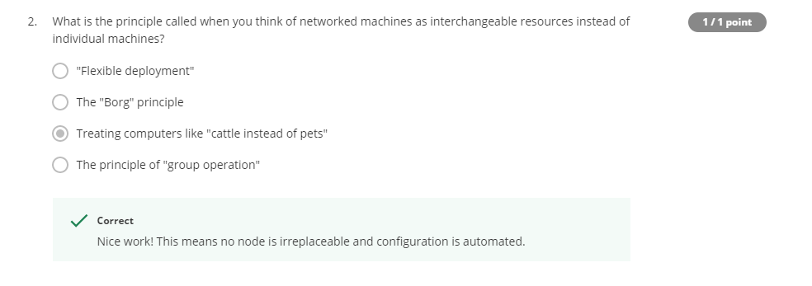

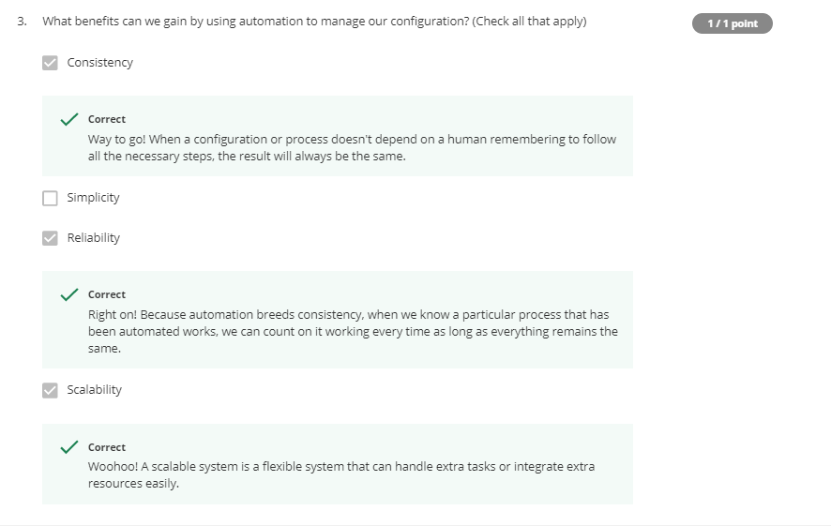

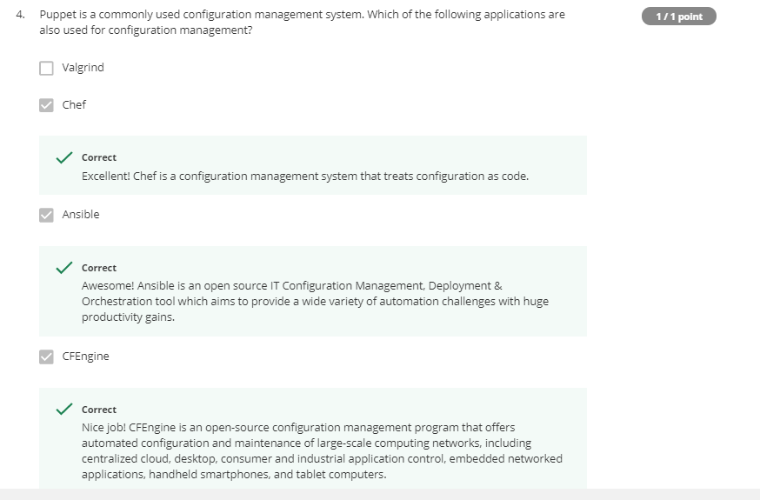

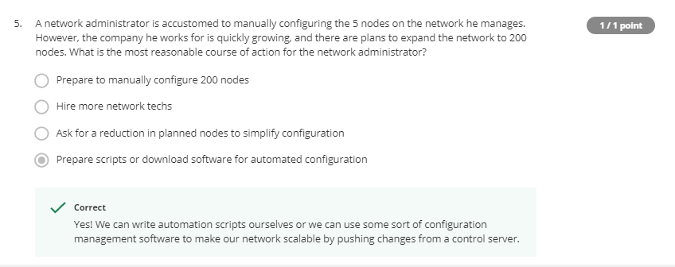

The tool we use for automation in cloud is Puppet.

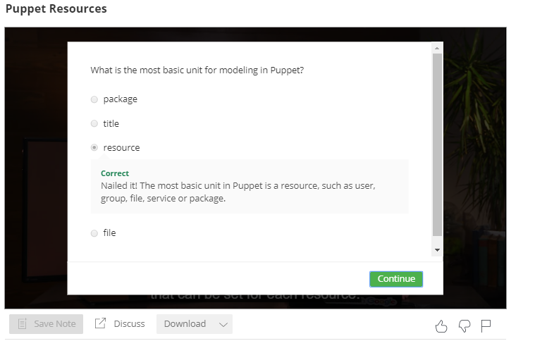

Puppet is like a programming language used for automation.

Puppet classes:-

Class ntp{

package{ ‘ntp’:

ensure => latest,

}

file{‘/etc/ntp.conf’:

source => ‘puppet:///modules/ntp/ntp.conf’,

replace => true,

}

service{‘ntp’:

enable => true,

ensure => running,

}

Understanding code:

Package 🡪 For package related configurations.

File 🡪 For file related configurations

Service 🡪 For service related configurations

The above three are called resources.

ensure in package 🡪 download latest package

replace in file 🡪 If present--replace it, or else install it.

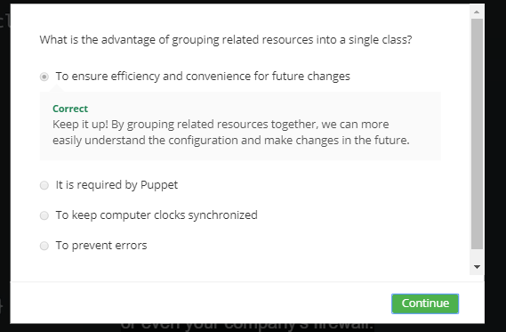

Syntax:

Resource_type{ ‘name’:

Attribute => value,

}

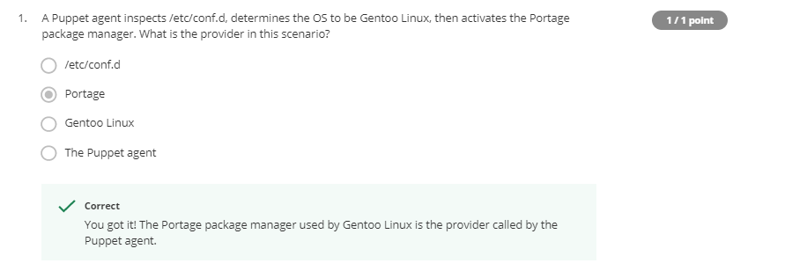

Puppet is a DSL (Domain Specific Language ) which is easy to learn than general purpose language.

Facts:

Variables that represents characteristics of system.

If $facts[‘is_virtual’] {

package{‘smartmontools’:

ensure => purged,

}

}

else{

package {‘smartmontools’:

ensure => installed,

}

}

Purged 🡪 remove a package

Puppet follows idempotent rule.

file{‘/etc/issue’:

mode => 0664,

content => “Internal system \l\n”,

}

If file is not there, it gets created.

If file has no permissions, it applies.

If file has different permissions, it modifies.

But, for this – the function should be idempotent.

exec { ‘move example file’:

command => ‘mv /home/user/example.txt /home/user/desktop’,

onlyif => ‘test -e /home/user/example.txt’,

}

If file exists then move takes place 🡪 making function idempotent using ‘onlyif’

Sudo apt install puppet-master 🡪 install puppet locally

Sudo puppet apply -v tools.pp 🡪 to run puppet file

class ntp{

package{'ntp':

ensure => latest,

}

file{'/etc/ntp.conf':

source => '/etc/ntp.conf',

replace => true,

require => Package['ntp'],

notify => Service['ntp'],

}

service{'ntp':

enable => true,

ensure => running,

require => File['/etc/ntp.conf'],

}

}

include ntp

notify 🡪 If conf file gets changed, it saves the changes and restarts the service.

Source 🡪 whre the file is present

Modules 🡪 contains manifests and files

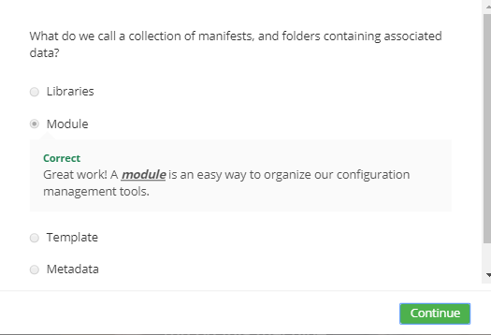

U can directly install and configure apache by downloading module from puppetlabs

Sudo apt install puppet-module-puppetlabs-apache